**A**

**PROJECT REPORT**

**ON**

**“<<DECLUTTER>>”**

**SUBMITTED TO**

**SHIVAJI UNIVERSITY, KOLHAPUR**

**IN THE PARTIAL FULFILLMENT OF THE REQUIREMENT**

**FOR THE AWARD OF DEGREE**

**BACHELOR OF TECHNOLOGY IN COMPUTER SCIENCE AND ENGINEERING**

**SUBMITTED BY**

|  |  |  |
| --- | --- | --- |
| **MISS.** | **SRUSHTI ABHIJEET PATIL** | **22UAD054** |
|  |  |  |
|  |  |  |
|  |  |  |

**UNDER THE GUIDANCE OF**

**Mr. S. P. Pise**

 



**DEPARTMENT OF ARTIFICIAL INTELLIGENCE AND DATA SCIENCE ENGINEERING**

**DKTE SOCIETY’S TEXTILE AND ENGINEERING INSTITUTE, ICHALKARANJI**

**(AN EMPOWERED AUTONOUMOUS INSTITUTE)**

**2024-2025**

**D.K.T.E. SOCIETY’S**

**TEXTILE AND ENGINEERING INSTITUTE, ICHALKARANJI**

**(AN EMPOWERED AUTONOUMOUS INSTITUTE)**

**DEPARTMENT OF ARTIFICIAL INTELLIGENCE AND DATA SCIENCE ENGINEERING**



**CERTIFICATE**

**This is to certify that, project work entitled**

**“<<DECLUTTER>>”**

**is a bonafide record of project work carried out in this college by**

|  |  |  |
| --- | --- | --- |
| **MISS.** | **SRUSHTI PATIL** | **22UAD054** |
|  |  |  |
|  |  |  |
|  |  |  |

**is in the partial fulfillment of award of degree Bachelor of Technology in Artificial Intelligence and Data Science Engineering prescribed by Shivaji University, Kolhapur for the academic year 2024-2025.**

**MR. S. P. PISE**

**(PROJECT GUIDE)**

**PROF. (DR.) T. I. BAGBAN PROF.(DR.) L.S.ADMUTHE**

**(HOD AI & DS DEPT.) (DIRECTOR)**

**EXAMINER: ________________**

**DECLARATION**

We hereby declare that, the project work report entitled “<<DECLUTTER>>” which is being submitted to D.K.T.E. Society’s Textile and Engineering Institute Ichalkaranji, affiliated to Shivaji University, Kolhapur is in partial fulfillment of degree B.Tech.(AI & DS). It is a bonafide report of the work carried out by us. The material contained in this report has not been submitted to any university or institution for the award of any degree. Further, we declare that we have not violated any of the provisions under Copyright and Piracy / Cyber / IPR Act amended from time to time.

|  |  |  |  |
| --- | --- | --- | --- |
| **Title** | **Name of the Student** | **PRN** | **Signature** |
| MISS. | SRUSHTI PATIL | 22UAD054 |  |
|  |  |  |  |
|  |  |  |  |
|  |  |  |  |

**ACKNOWLEDGEMENT**

With great pleasure we wish to express our deep sense of gratitude to Mr. S. P. Pise for his valuable guidance, support, and encouragement in the completion of this project report.

Also, we would like to take the opportunity to thank our head of department Dr. T. I. Bagban for his cooperation in preparing this project report.

We feel gratified to record our cordial thanks to other staff members of the Artificial Intelligence and Data Science Department for their support, help, and assistance which they extended as and when required.

Thank you,

|  |  |  |
| --- | --- | --- |
| **Title** | **Name of the Student** | **PRN** |
| MISS. | SRUSHTI PATIL | 22UAD054 |
|  |  |  |
|  |  |  |
|  |  |  |

**ABSTRACT**

This task management website is a comprehensive digital solution designed to streamline task organization and productivity management for individuals and teams. Developed using modern web technologies including HTML, Tailwind CSS, JavaScript, and backed by a secure node.js server with a MySQL database, the platform offers essential functionalities such as task creation, categorization, progress tracking, and user account management. The system ensures secure data handling and provides an intuitive, responsive interface to enhance user engagement, making it an effective tool for managing workloads and improving operational efficiency.

Imagine a workspace where your to-dos are no longer chaotic lists, but neatly organized, colorful tasks that move, grow, and evolve with you. This task management website transforms everyday productivity into a playful, visually engaging experience. With seamless task creation, easy editing, vivid progress bars, and real-time updates, users can effortlessly keep track of goals and milestones. The friendly, interactive dashboard, backed by secure server-side processing and a robust MySQL database, ensures your tasks are not just managed — they come to life

Task management website offers an efficient and scalable productivity platform tailored for businesses and teams seeking to optimize task coordination and workflow management. Featuring a sleek, responsive interface built with HTML, Tailwind CSS, and JavaScript, the platform supports task categorization, progress tracking. Designed to enhance operational visibility and team collaboration, this platform provides actionable insights and tools essential for maintaining productivity in dynamic work environment.

**INDEX**

1. **Introduction Page no. 1** 
   1. Problem definition
   2. Aim and objective of the project
   3. Scope and limitation of the project
2. **Background study and literature overview Page no. 4**
   1. Literature overview
   2. Investigation of current project and related work
3. **Requirement analysis Page no. 6**

a. Requirement Gathering

b. Requirement Specification

c. Use case Diagram

1. **System design Page no. 8**
   1. Architectural Design
   2. Dataflow Diagram
2. **Implementation Page no. 9**

a. Agile Methodologies

b. Development Model

1. **Future Scope Page no. 10**
2. **References (Public repository GitHub source code links) Page no. 12**

**1. Introduction**

1. **Problem definition:**

In today’s fast-paced digital world, individuals and teams often struggle to effectively manage their personal and collaborative tasks. Many people rely on scattered methods such as sticky notes, spreadsheets, and mobile apps that lack consistency, synchronization, and proper organization. This leads to missed deadlines, disorganized workflows, and reduced productivity.

While there are existing task management tools available, many of them are either too complex, difficult to use, or lack customization and accessibility for casual users and small teams. Moreover, these tools often come with unnecessary features that complicate the user experience or require paid subscriptions for basic functionality.

To address these challenges, this project proposes the development of a simple, accessible, and user-friendly task management website. The platform will allow users to register, create and categorize tasks, track progress, and receive real-time notifications — all through an interactive and playful web interface. By connecting a responsive frontend with a reliable backend server and database, this website aims to offer a seamless, effective, and enjoyable task management experience for individuals and small teams.

1. **Aim and objective of the project:**

The aim of this project is to design and develop a user-friendly, web-based task management system that enables individuals and small teams to efficiently organize, track, and manage their tasks through an interactive and responsive platform

• Todesign an intuitive, responsive, and visually engaging frontend interface using HTML, Tailwind CSS, and JavaScript for seamless user interaction across devices.

• Toimplement secure backend services using Node.js, Express, and a MySQL database for user authentication, task storage, and data management.

• Toenable task creation, editing, deletion, and categorization, allowing users to efficiently organize their personal and work-related activities.

• Tointegrate task progress tracking and real-time notifications for improved task visibility, status updates, and user productivity.

• Toensure smooth communication between frontend and backend systems via RESTful API requests through http://localhost:3000/.

• Toprovide a secure user account management system including registration, login, and personal task dashboards.

• Totest and optimize the website for usability, performance, and responsiveness on different devices and browsers.

1. **Scope and limitation of the project:**

The scope of this project includes the development of a **task management platform** aimed at personal and small team productivity. Key features and functionalities within the scope include:

1. **User Accounts and Authentication:**

User registration, login, and secure session management.

1. **Task Management**
   1. Task creation, editing, deletion, categorization, and prioritization.
   2. Progress tracking with visual indicators (e.g., progress bars).
2. **Notifications:**

Task reminders and progress update notifications.

1. **Responsive Design:**

A mobile-responsive interface ensuring usability on different devices (desktop, tablet, mobile).

1. **Backend Integration:**

Server-side functionality for managing tasks, users, and data stored in MySQL.

1. **Simple API Requests:**

Communication between frontend and backend via RESTful APIs, allowing dynamic data updates.

1. **Testing and Deployment:**

Basic usability testing to ensure the platform functions as intended in real-world scenarios.

While the project aims to provide a functional and user-friendly task management system, several limitations are present due to time, resource, and technical constraints

1. The platform will focus primarily on basic task management, with no advanced features such as task dependencies, file attachments, or integration with third-party services (e.g., Google Calendar, Slack).
2. The platform will only provide a web-based interface, without any mobile app for iOS or Android.
3. The website will be designed to handle small-scale usage (i.e., individual users or small teams), and may not scale efficiently for large numbers of users or high traffic.
4. The platform will require an internet connection for all features and will not have offline capabilities.

**2. Background study and literature overview**

1. **Literature overview:**

The increasing reliance on digital tools for personal and team productivity has made task management an essential part of modern work culture. As individuals and teams strive for greater efficiency, they face challenges in keeping tasks organized, setting priorities, tracking progress, and managing deadlines. The need for effective task management systems has grown across all sectors, from small businesses to large enterprises.

Historically, task management solutions have evolved from paper-based systems and basic lists to more sophisticated software applications. Early tools like **to-do lists** and **bullet journals** were simple but lacked flexibility and integration. As digital solutions emerged, productivity tools like **Trello**, **Asana**, and **Todoist** gained popularity, offering a variety of features such as task categorization, prioritization, notifications, and project tracking. However, many of these systems are complex, feature-heavy, and often come with subscription costs, making them less accessible to casual users and small teams.

The need for a simpler, cost-effective solution that combines the basic yet powerful functionalities of task creation, tracking, and categorization, without the overhead of complex features, led to the idea for this project. By focusing on user-friendliness and clear task management capabilities, the proposed platform aims to address the gap between over-complicated tools and simple, non-digital methods.

1. **Investigation of current project and related work:**

Research by **MacLeod and Ward (2015)** indicates that **task organization** is crucial for improving efficiency, reducing stress, and enhancing focus. Well-organized task management can help prevent procrastination and improve task prioritization, leading to higher levels of productivity. A **study by Herzberg (2016)** on task-oriented workflows found that clear progress tracking and visual cues (such as progress bars or status indicators) significantly enhance user satisfaction and completion rates.

Several task management systems are widely used in both personal and professional environments. **Trello**, **Asana**, and **Todoist** are popular examples that focus on project management and team collaboration. According to **Harvard Business Review (2018)**, tools like these are highly valued for their ability to integrate various aspects of task management, such as delegation, reminders, and progress tracking. However, many of these tools tend to overwhelm users with too many features, and as noted by **Jones (2019)**, they often come with subscription fees, making them less accessible for casual users or small teams.

The design of user interfaces plays a critical role in the success of task management platforms. **Nielsen Norman Group (2019)** emphasizes that simplicity and clarity in task management tools are vital for enhancing usability. Intuitive design elements such as **drag-and-drop interfaces**, **color-coded categories**, and **progress bars** help users stay organized and motivated. A **study by Preece et al. (2015)** showed that user-friendly interfaces significantly improve the likelihood of tool adoption and regular use.

**3. Requirement analysis**

1. **Requirement Gathering:**

**Stakeholders:**

* **End-users** (individuals or small teams managing tasks).
* **Developers** (for building the system).
* **Project Manager** (overseeing the project).
* **System Administrator** (managing backend maintenance).

#### **Functional Requirements:**

1. **User Accounts:**
   * Registration, login, profile updates, and password recovery.
2. **Task Management:**
   * Create, edit, delete, and categorize tasks.
   * Add task details like due date, priority, and progress.
3. **Progress Tracking:**
   * Visual progress indicators and notifications.
4. **Dashboard:**
   * Display active, overdue, and upcoming tasks.
5. **API Integration:**
   * Frontend and backend communication through RESTful APIs.

#### **Non-Functional Requirements:**

1. **Usability:**
   * Simple, intuitive interface.
2. **Performance:**
   * Fast loading and responsive task operations.
3. **Security:**
   * Secure password storage and HTTPS for communication.
4. **Scalability:**
   * Ability to support increasing users and tasks.
5. **Accessibility:**
   * Mobile responsiveness and accessibility features.

#### **Technical Requirements:**

1. **Frontend:** HTML, CSS, JavaScript, Tailwind CSS.
2. **Backend:** Node.js, Express, MySQL database.
3. **Deployment:** Hosted on a cloud platform (e.g., AWS, Heroku).

1. **Use case Diagram:**

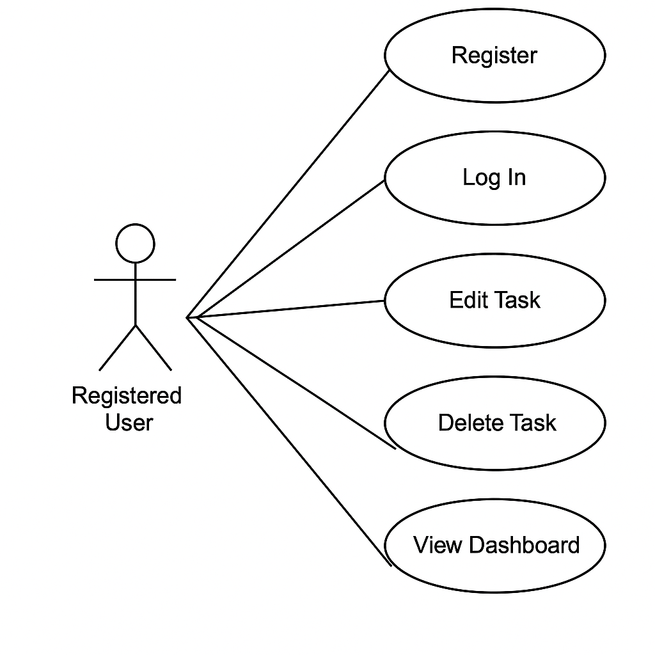

**4. System design**

**Architecture diagram:**

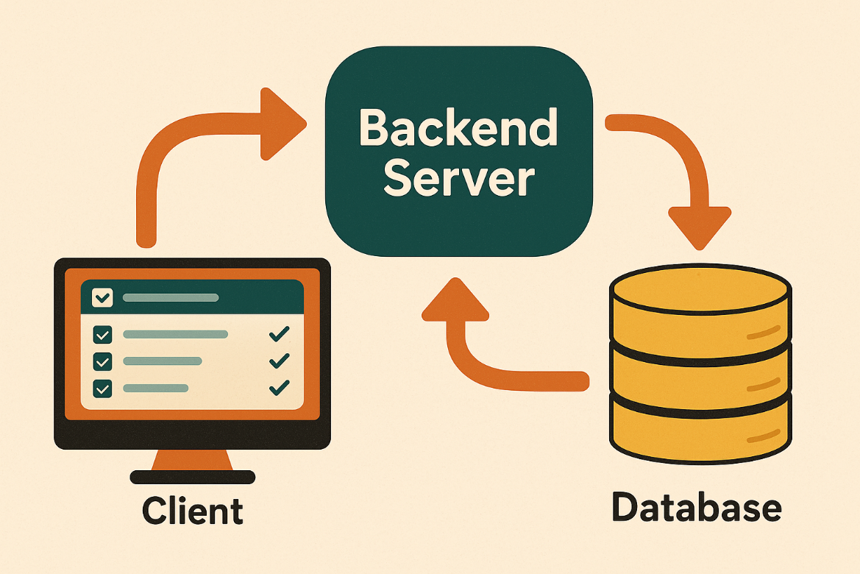

**Dataflow Diagram:**

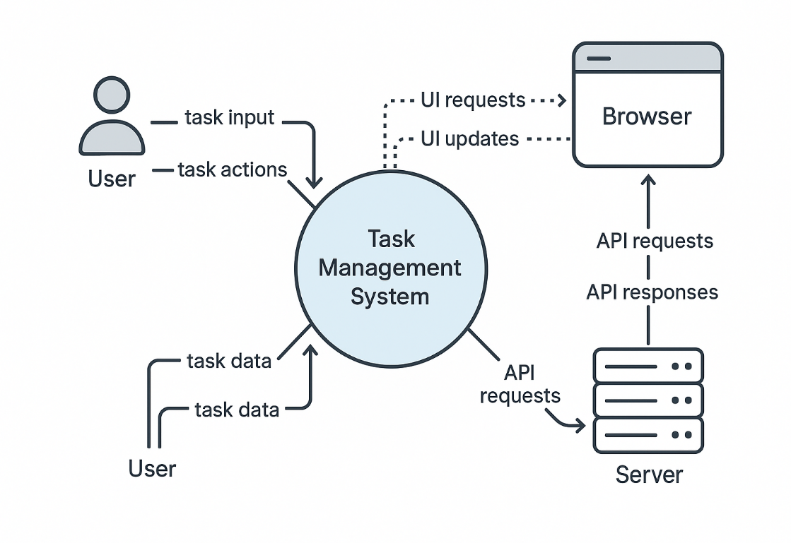

**5. Implementation**

This project is iterative, user-driven, and may evolve based on feedback. Agile is perfect because it:

* Encourages **frequent releases**.
* Adapts to **changing requirements**.
* Prioritizes **user feedback and collaboration**.
* Delivers working software in **incremental, functional pieces**

| **Phase** | **Description** |
| --- | --- |
| **Requirement Gathering** | Collect and prioritize requirements from users and stakeholders. |
| **Sprint Planning** | Break down work into small, manageable sprints (1-2 weeks). |
| **Design** | Design wireframes, UI mockups, and architecture diagrams. |
| **Development** | Implement features in short sprints (using HTML, CSS, JS, Node.js, MySQL). |
| **Testing** | Test functionalities in each sprint — both manually and through automation. |
| **Sprint Review** | Present completed work to stakeholders and gather feedback. |
| **Deployment** | Deploy tested and accepted features to the live or staging environment. |
| **Sprint Retrospective** | Review what went well, what didn’t, and how to improve the next sprint. |

### ****Why Scrum?****

Your task management website project involves:

* **Incremental development** (you’ll keep adding features — like task categories, progress tracking, notifications, etc.)
* **Frequent feedback cycles** (from yourself, users, or stakeholders)
* **Changing priorities** (features like notifications or progress bars might need improvements based on use)
* A small, focused development team (even if it’s just you initially!)

**6. Future Scope**

**Future Scope for a Task Management Website:**

Mobile App Integration: Native apps for Android/iOS with real-time sync.

Team Collaboration: Shared boards, comments, and file sharing.

Calendar & Reminders: Integrate with Google Calendar or native notifications.

Progress Analytics: Track task completion rates, deadlines, and team productivity.

Customizable Workflows: Let users build their own task stages and categories.

Cloud Sync & Backup: Secure, automatic backups and cross-device sync.

User Roles & Permissions: Admin, editor, viewer roles in multi-user environments.

Dark Mode & Accessibility Features: Improve UX and inclusivity.

**AI Features You Could Add:**

1. Smart Task Suggestions

Predict and suggest new tasks based on previous habits or deadlines.

Example: “You usually add a ‘Weekly Report’ on Mondays — want to create it now?”

2. Natural Language Input

Users type something like “Finish project presentation by Friday” — AI turns it into a task with a deadline automatically.

3. Priority Prediction

AI evaluates task urgency and importance based on keywords, deadlines, or user behavior and assigns priorities.

4. Smart Reminders

AI learns when you usually work best and suggests reminders at optimal times.

5. Deadline Risk Detection

Alerts if it predicts a task might miss its deadline based on progress and historical patterns.

6. Task Categorization

AI automatically classifies tasks into categories (Work, Personal, Urgent, etc.) using keyword analysis.

7. Productivity Insights

Analyze user data to give AI-powered suggestions like: “You complete 80% of tasks before noon. Focus on critical work in the morning!”

8. Voice Command Integration

Use speech-to-text AI for adding, editing, or marking tasks.

**7. References (public repository GitHub source code links)**

[**https://github.com/PatilSrushti2004/Mini-Project**](https://github.com/PatilSrushti2004/Mini-Project)